DEPLOY IN KUBERNETES CLUSTER

|  |  |
| --- | --- |
| **Team ID** | PNT2022TMID47506 |
| **Project Name** | Smart Fashion Recommender Application |
| **Team Members** | Seeman S  Arun N  Prakash S  Deepanraj S  Thirukabilan S |

KUBERNETES WORKER NODE

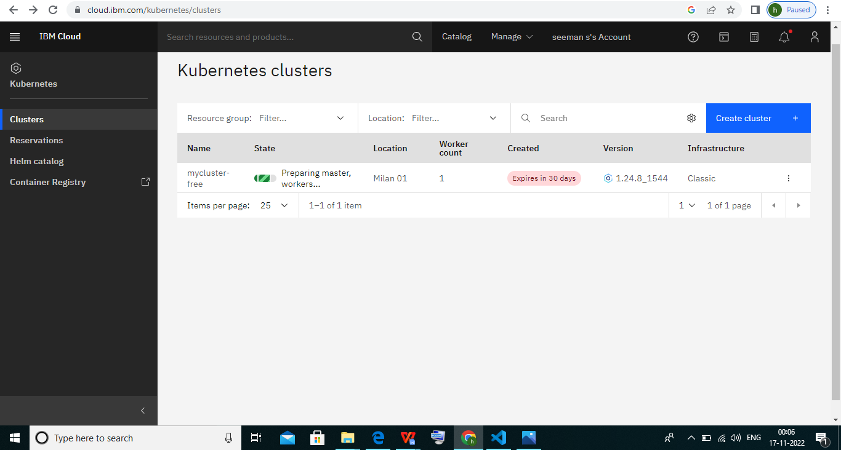

KUBERNETES DEPLOYMENT:

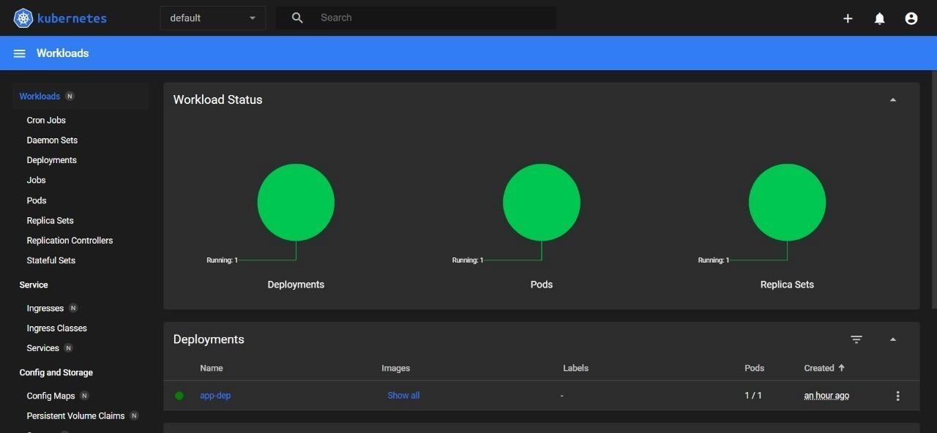

KUBERNETES SERVICE PODS:

